**Name: Victoria Jacqueline Macías Pico**

**W O R K S H E E T S**

**NOTE:** **Your answers must be in blue and bold.**

# UNIT 9



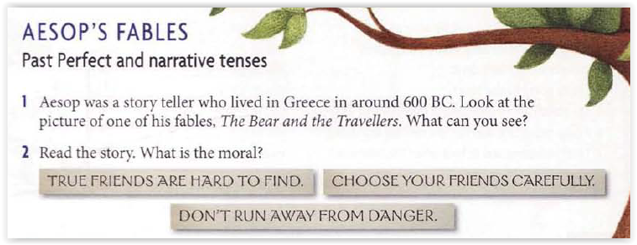



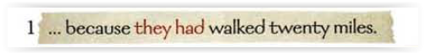

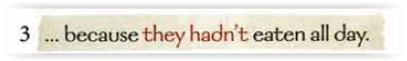

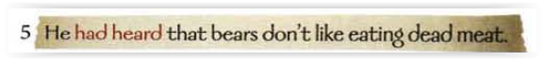

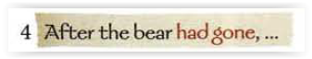

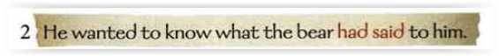



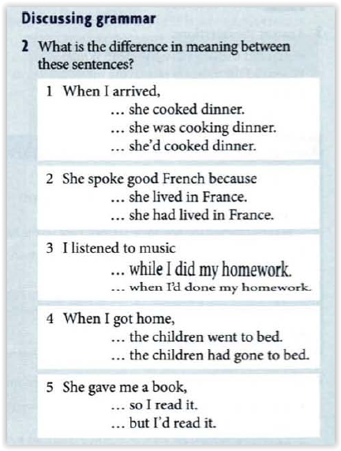

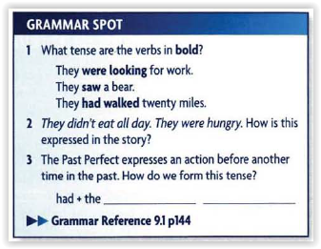

**Past participle**

**1. Write the PAST PARTICIPLE (3rd form) of the following irregular verbs:**

|  |  |  |  |
| --- | --- | --- | --- |
| **VERB** | **PAST PARTICIPLE** | **VERB** | **PAST PARTICIPLE** |
| **Think** | **thought** | **Throw** | **thrown** |
| **sleep** | **slept** | **swim** | **swum** |
| **wear** | **worn** | **go** | **gone** |

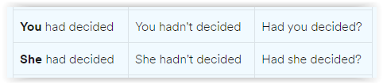

**1. Complete the sentences below with the simple form of PAST PERFECT:**

1. I thought I knew her. I thought I  **had seen**  (see) her before.
2. He  **had driven**  (drive) only twice in his life before the accident.
3. Keyla no longer had her car. She  **had sold**  (sell) it.
4. When I saw Anie last week. She  **had changed**  (change) a lot.
5. When I arrived home, Lily  **had just gone**  (just go) out.

**2. Complete the sentences using the NEGATIVE FORM OF PAST PERFECT.**

* ***Example:*** He ________ (leave) when I arrived. 🡪 He **hadn't left** when I arrived.

1. I saw him because he  **hadn’t left**  (leave) for work.
2. The girl was afraid. She  **hadn’t flown**  (fly) on a plane before.
3. Kevin was happy to see Ana again. They  **hadn’t met**  (meet) for a long time.
4. He didn't get the job because he  **hadn’t sent**  (send) all his papers.
5. I  **hadn’t saved**  (save) my document before the computer crashed.

**3. Complete the QUESTIONS in Past Perfect Simple.**

1. (what / Amy / do)  **what had she done**  that she was kept in after school?
2. (you / eat)  **had you eaten**  anything before you went to the theatre?
3. (he / live)  **had she lived**  in Madrid before he moved to Paris?
4. (she / find)  **had she found**  a new job by that time?
5. (they / book)  **had the booked**  a room before they went to Mexico?

**4. Complete the sentences with SIMPLE PAST & PAST PERFECT:**

1. It  **started**  to rain after we  **had got**  to the station. (start / get)
2. We  **visited**  the village where we  **had lived**  as children. (visit / live)
3. By the time we  **reached**  the inn all the guests  **had left** . (reach / leave)
4. We  **met**  him just after he  **had got**  news of his dismissal. (meet / get)
5. Nobody  **knew**  where she  **had gone**  . (know / go)

**5. Highlight the conjuntioncs you find on the sentences above.**

**PRACTICE:** <https://www.examenglish.com/grammar/B1_past_perfect.htm>

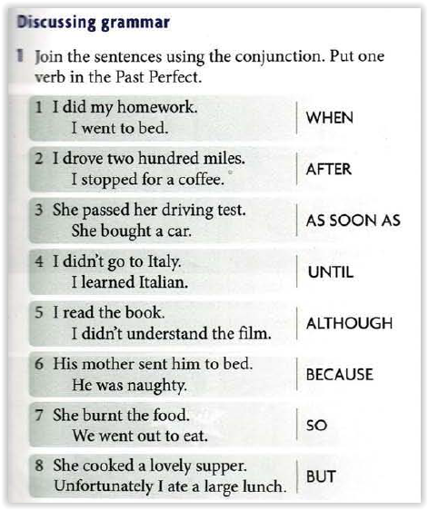

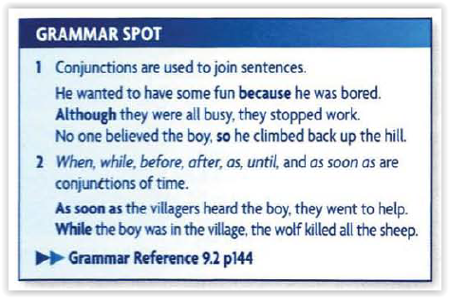

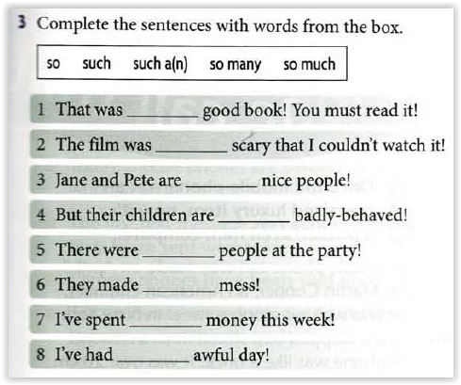

**Such a**

**So**

**Such a**

**So**

**So many**

**Such a**

**So much**

**Such an**